**CSA0718 - COMPUTER NETWOKS**

**EXPERIMENT -1**

**NETWORK DEVICES**

**A.HUB**

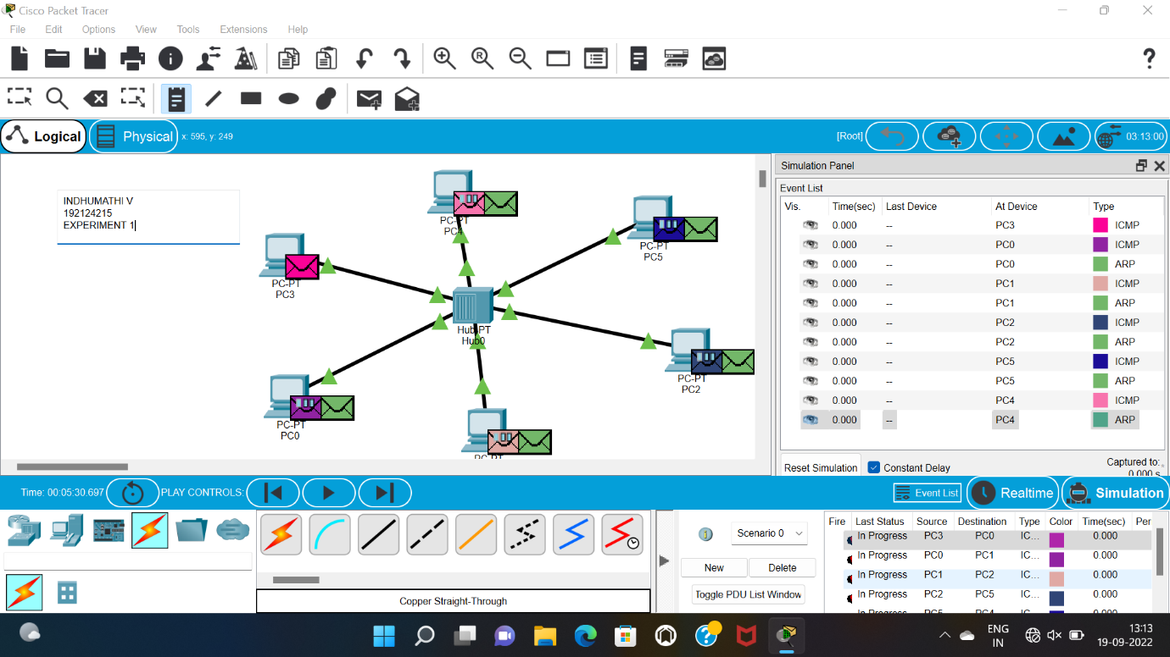

**B.SWITCH**

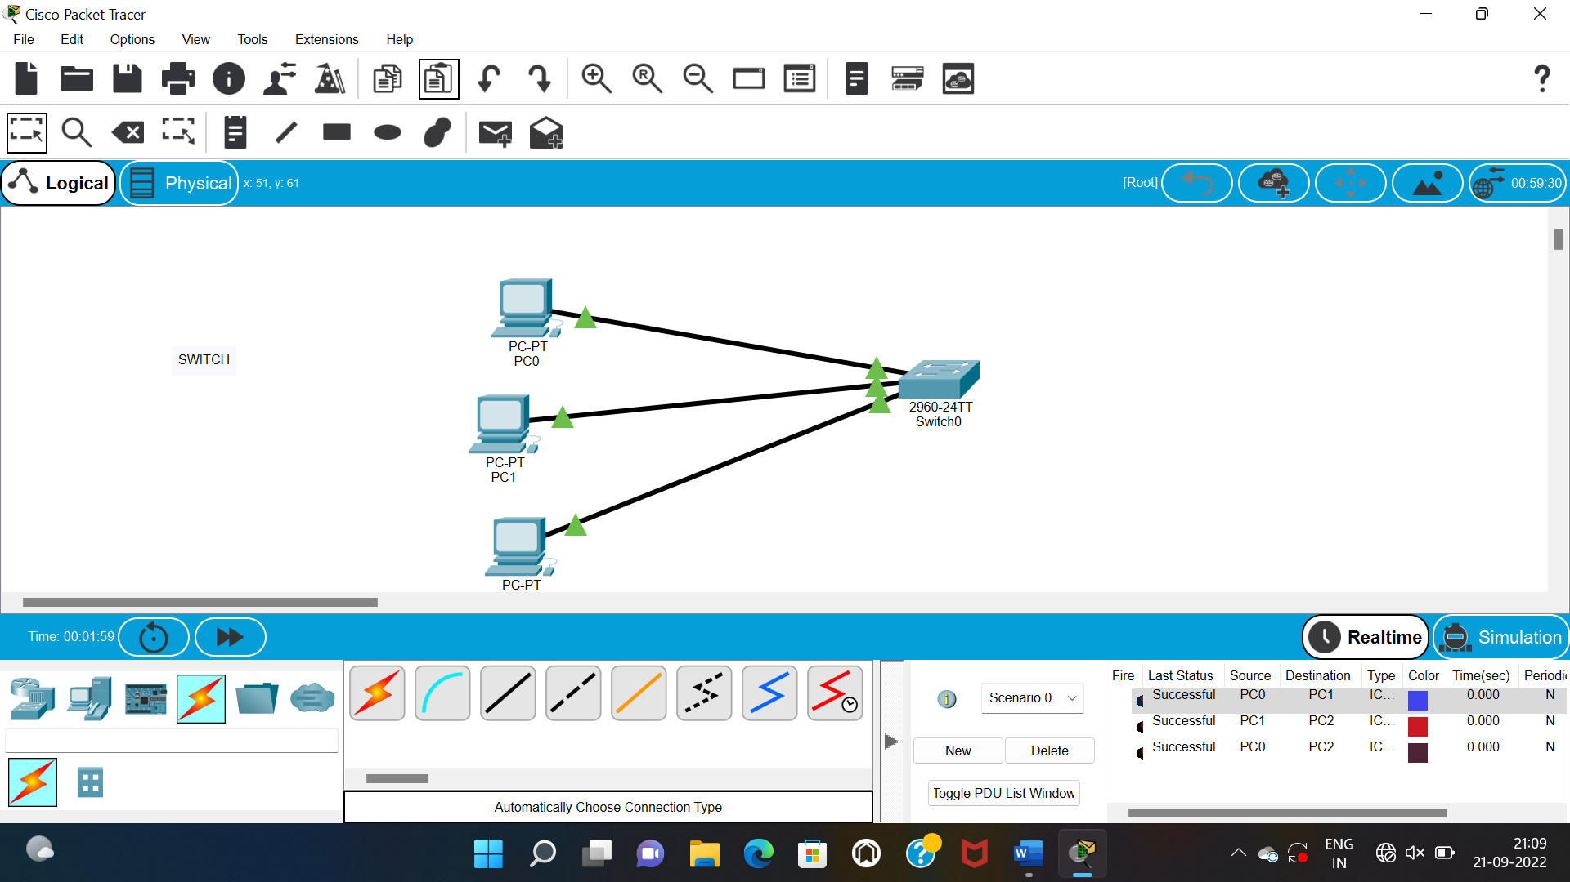

**C.ETHERNET**

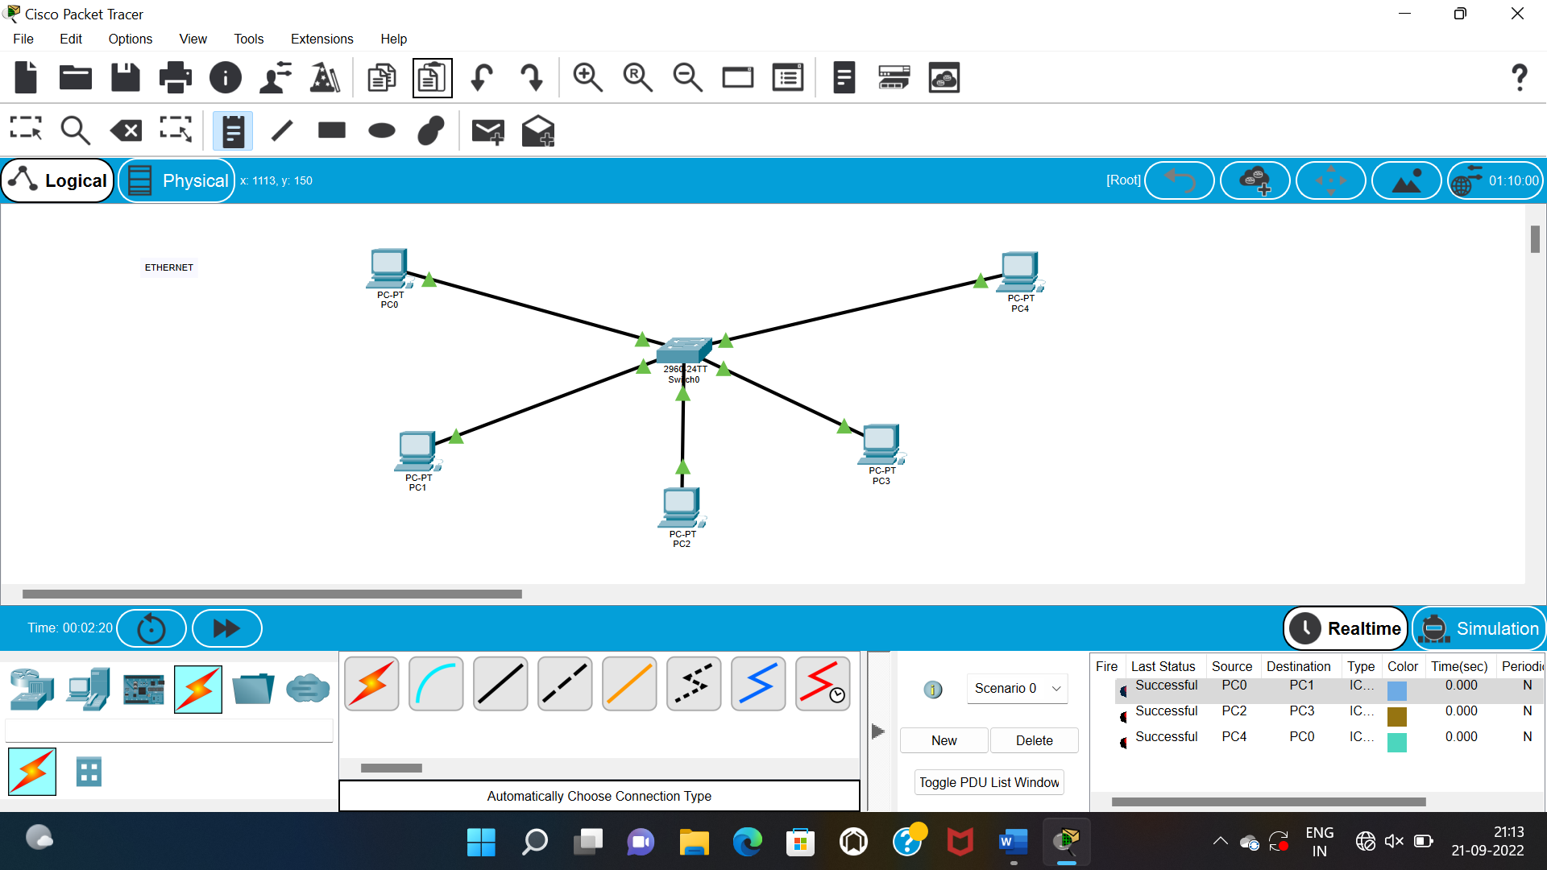

**EXPERIMENT -2**

**CONFIGURATION OF TOPOLOGY**

**A.STAR TOPOLOGY**

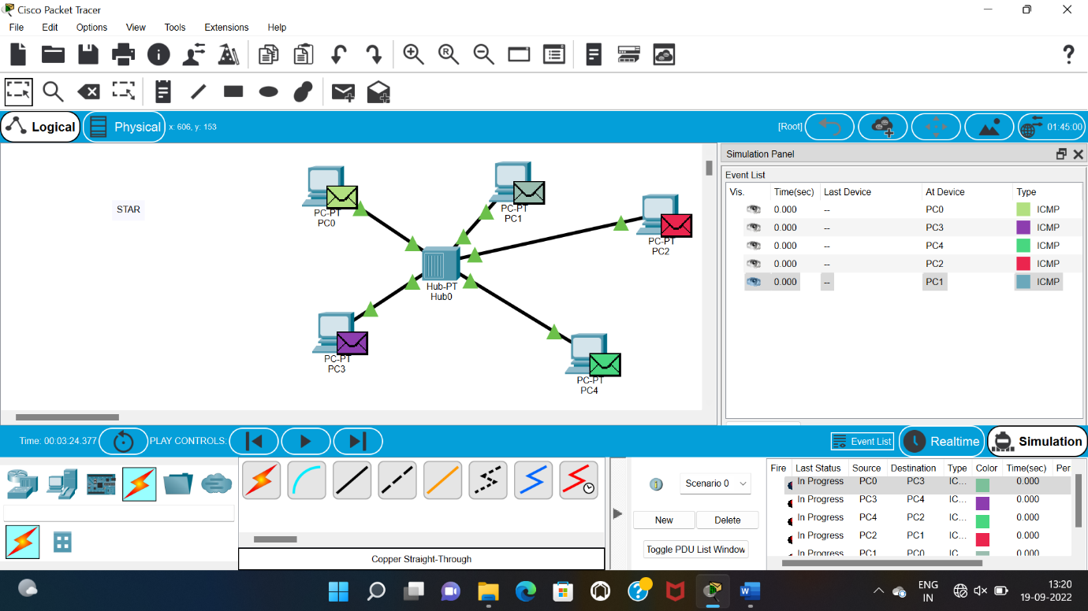

**B.BUS TOPOLOGY**

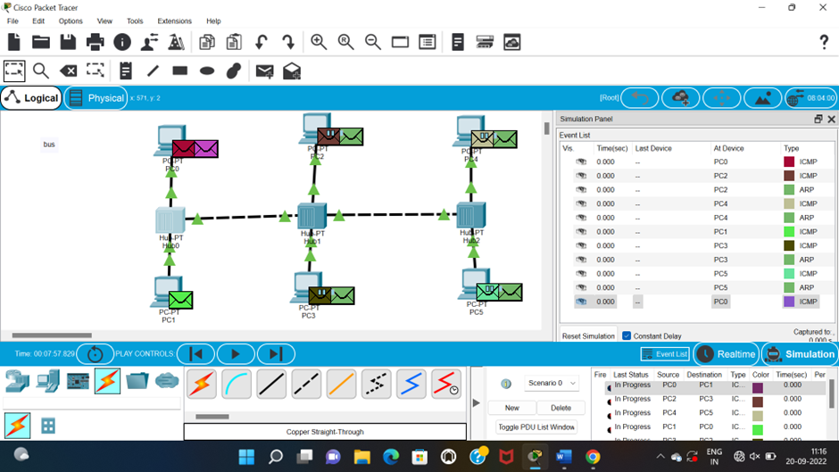

**C.MESH TOPOLOGY**

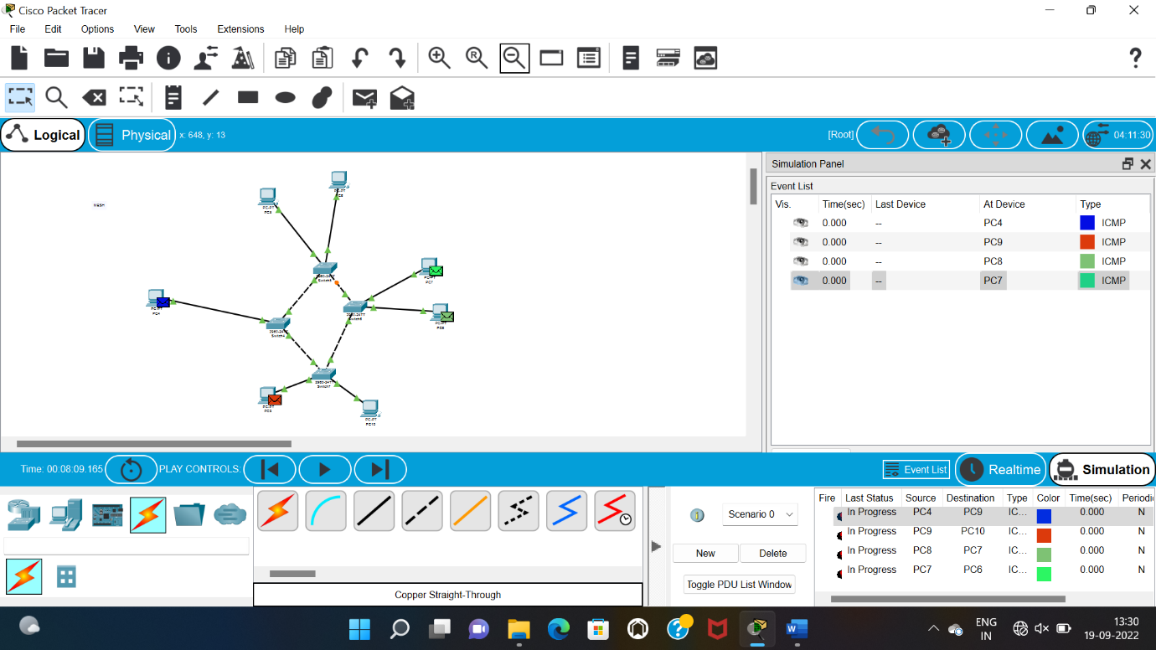

**EXPERIMENT 3**

**CONFIGURATION OF TOPOLOGY**

**A.BUS TOPOLOGY**

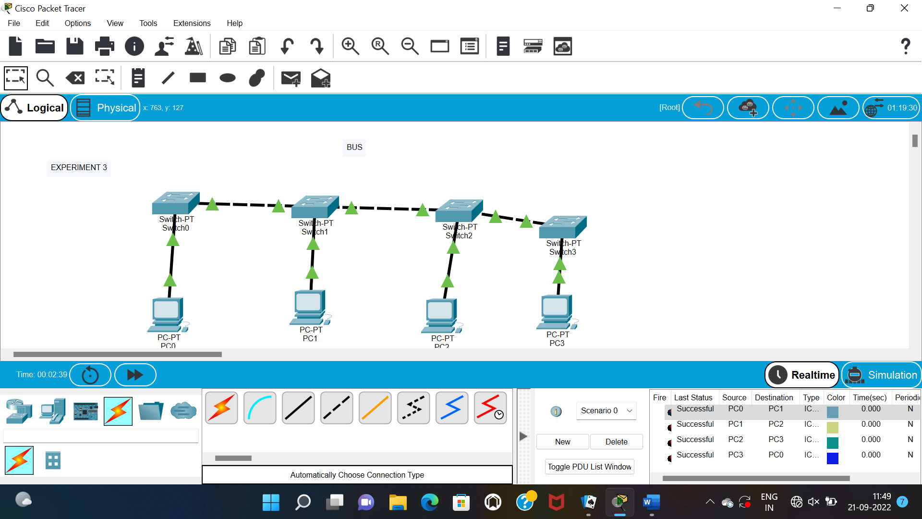

**B.TREE TOPOLOGY**

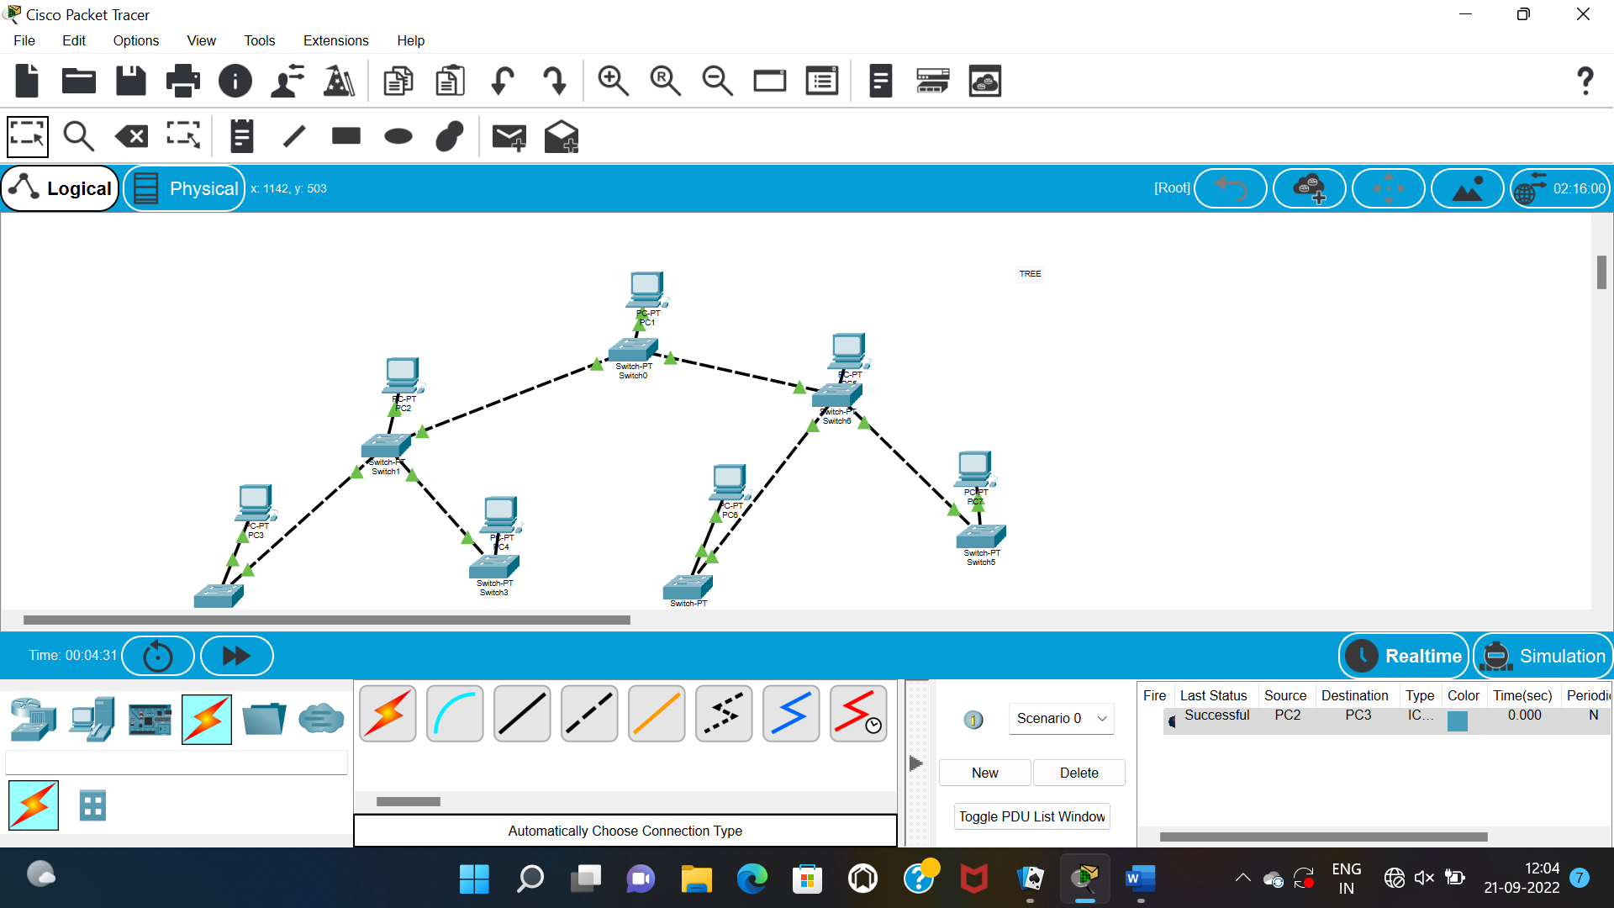

**C.RING TOPOLOGY**

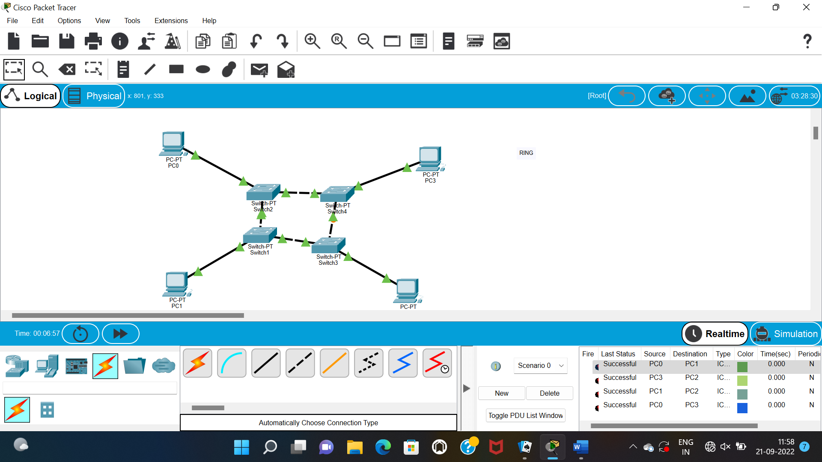

**EXPERIMENT 4**

**CASM/CD &CSMA/CA**

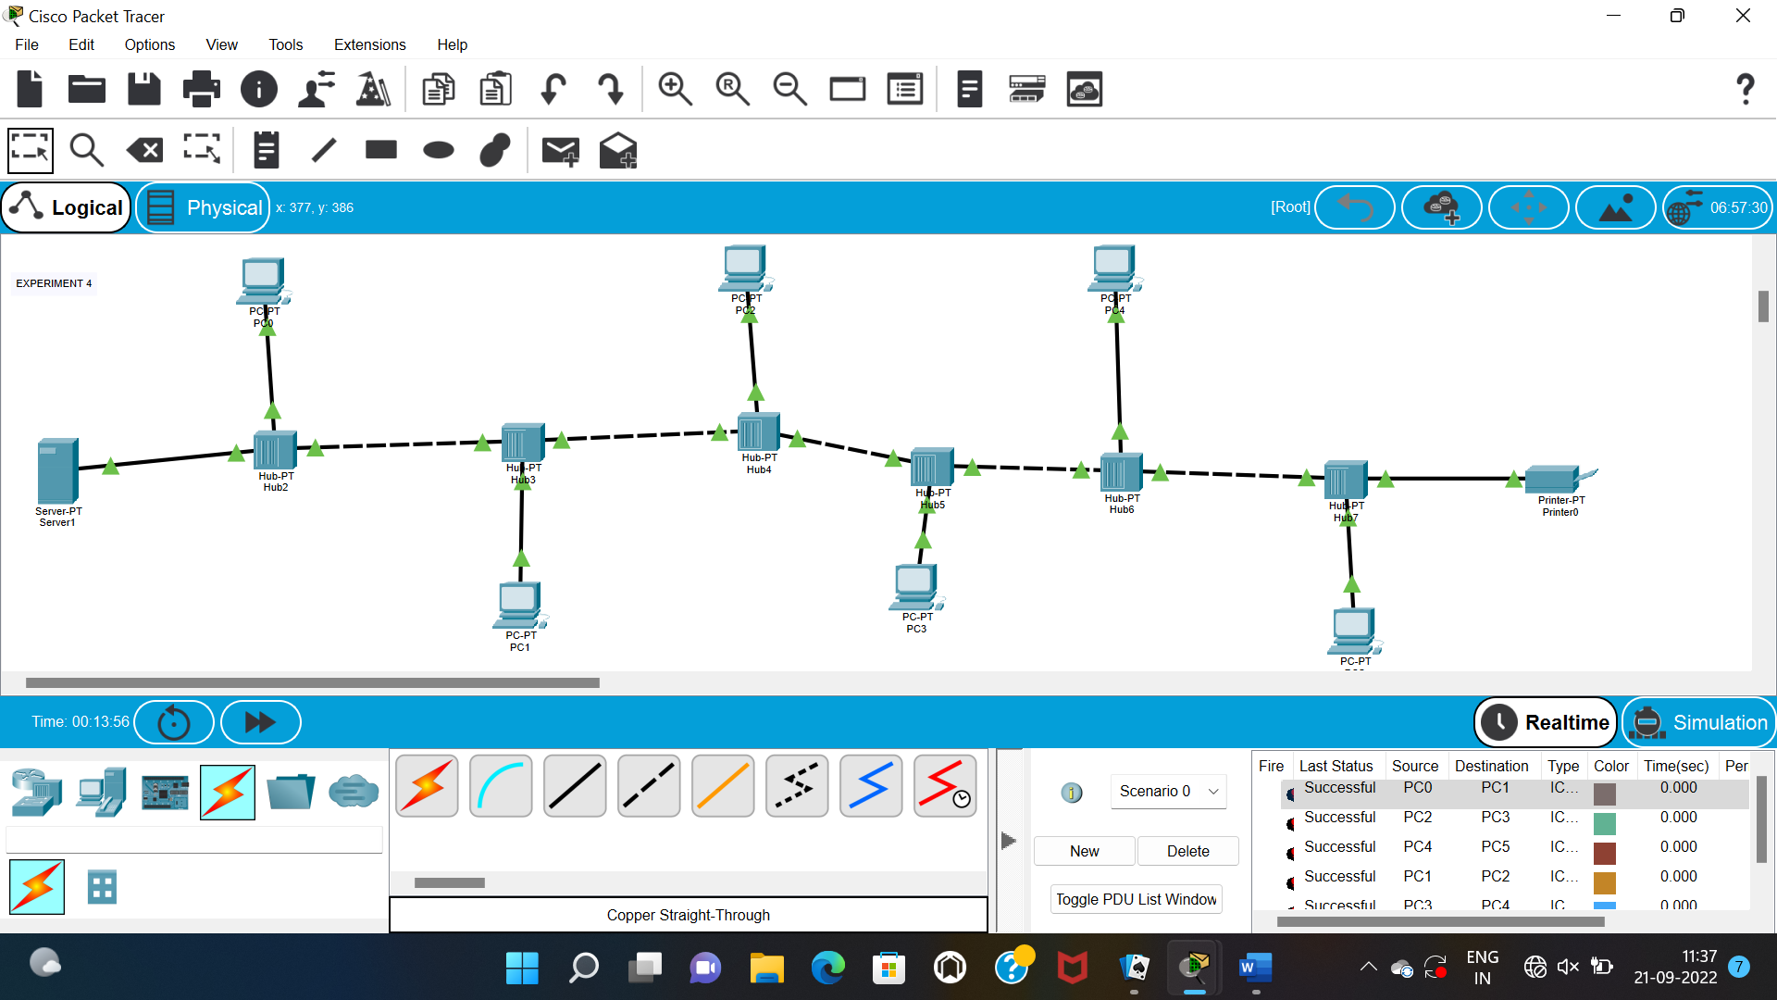

**EXPERIMENT 5**

**DATA LINK LAYER TRAFFIC SIMULATION USING PACKET TRACKER ANALYSIS OF APR**

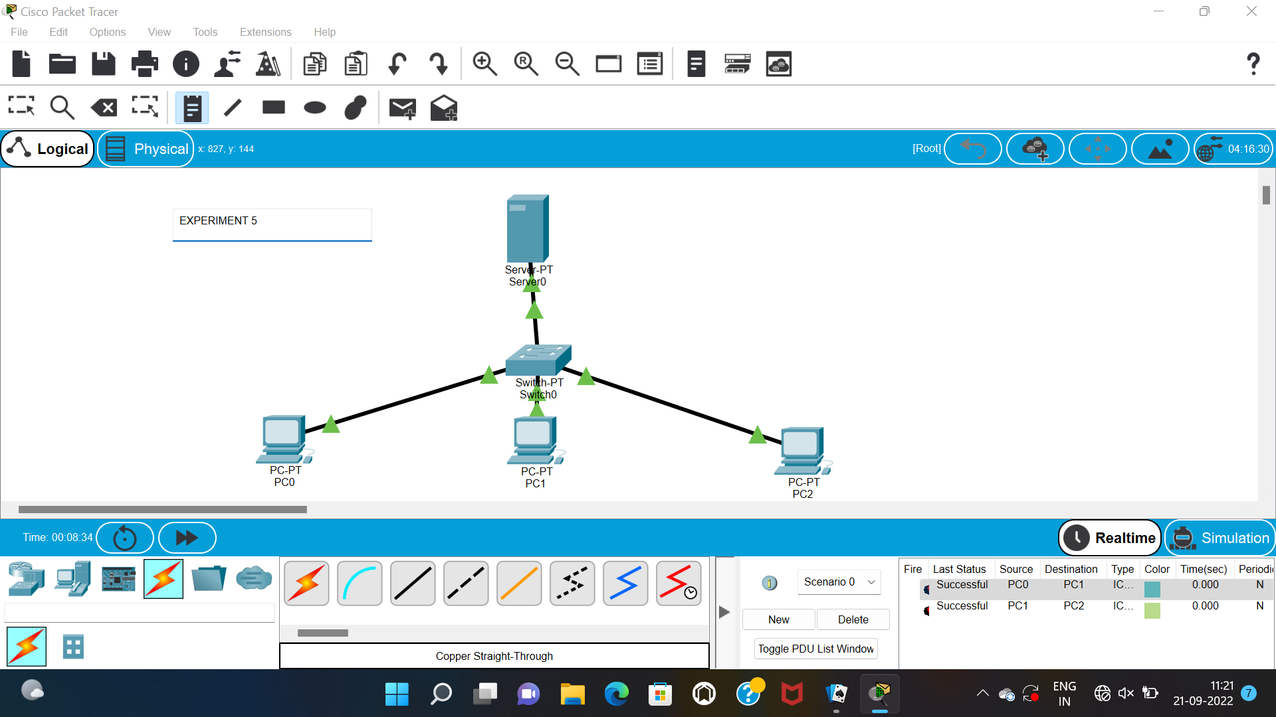

**EXPERIMENT 6**

**STATIC ROUTING USING PACKET TRACER**

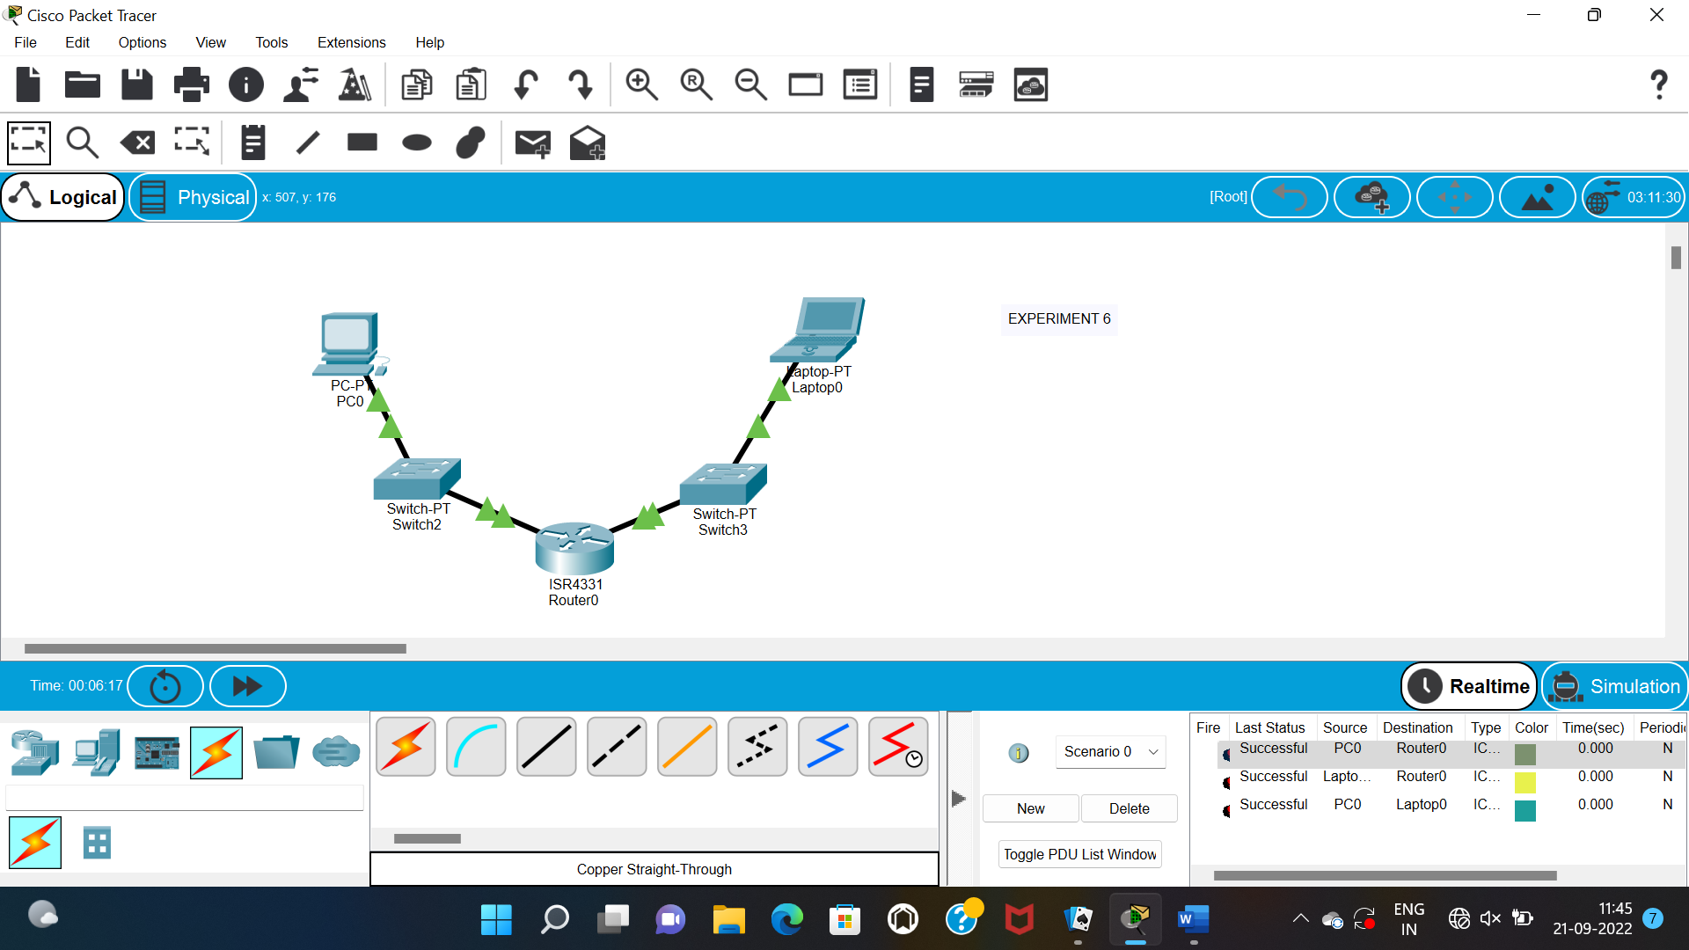

**EXPERIMENT 7**

**DYNAMIC ROUTING USING PACKET TRACER(OSPF)**

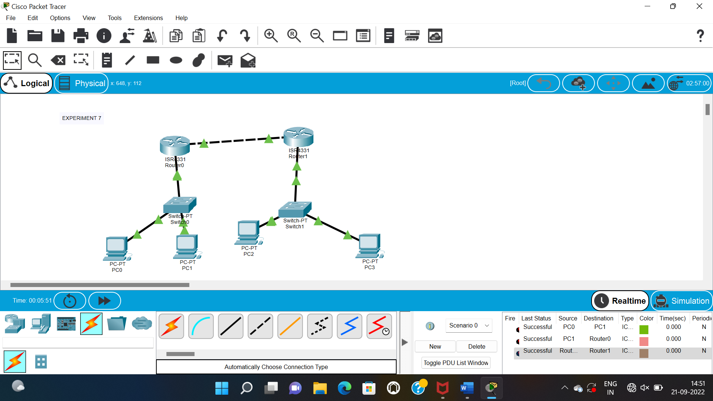

**EXPERIMENT 8**

**SUBNETTING-CLASS C ADDRESSING**

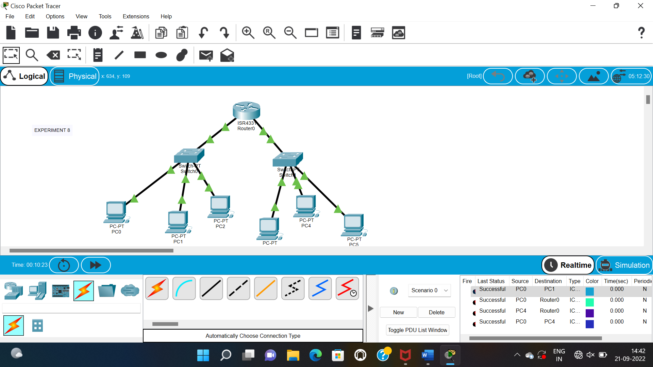

**EXPERIMENT 9**

**FUNCTIONS OF UDP**

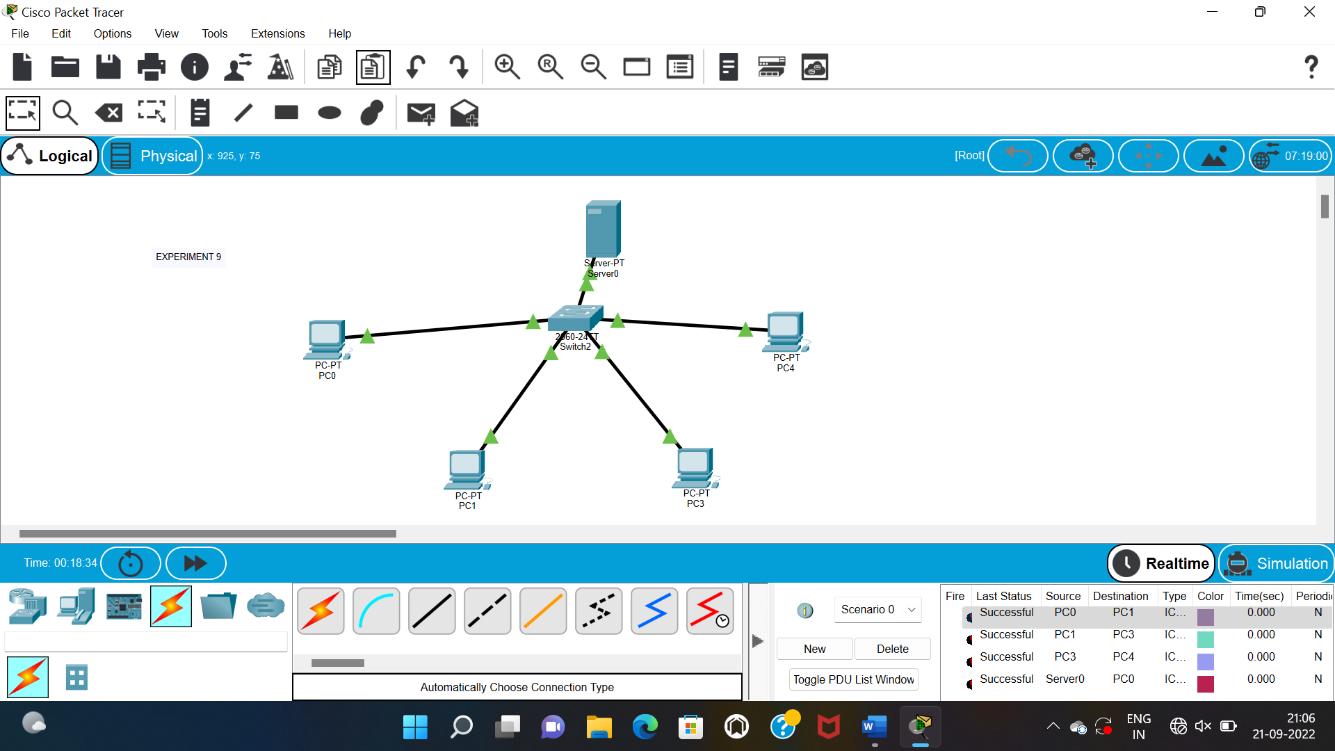

**FUNCTIONS OF TCP**

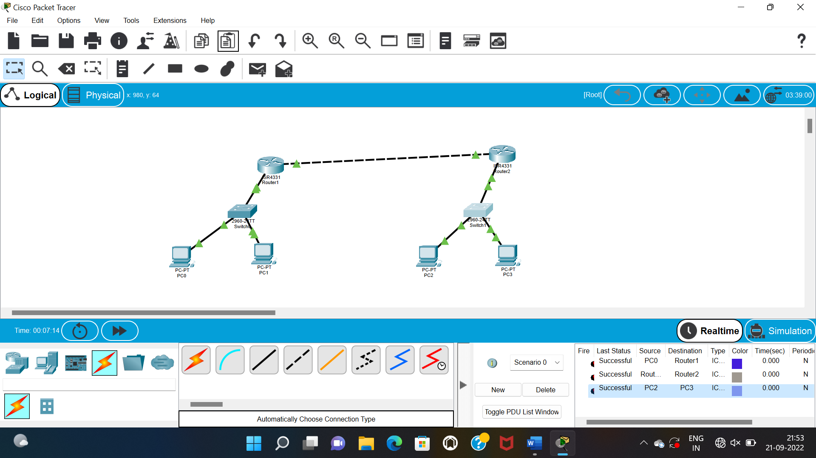

**EXPERIMENT 10**

**TCP EXPLORATION SOLUTION**

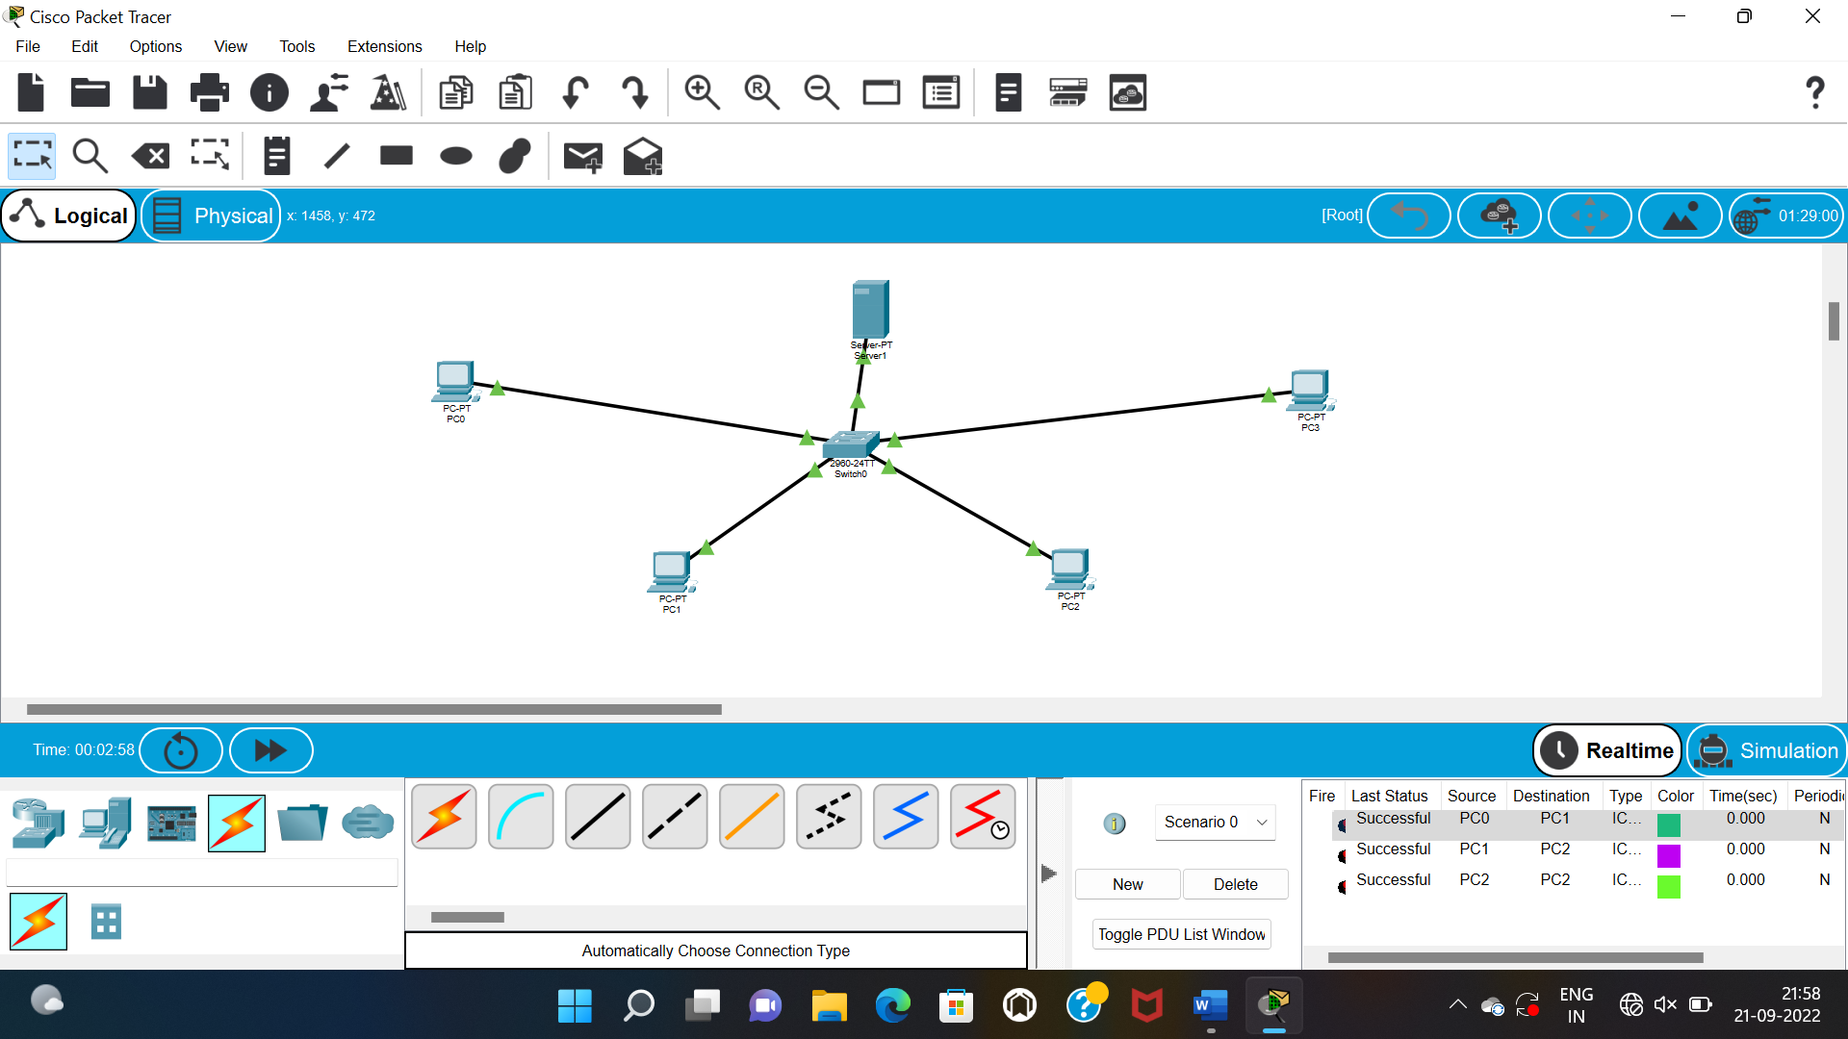

**UDP EXPLORATION SOLUTION**

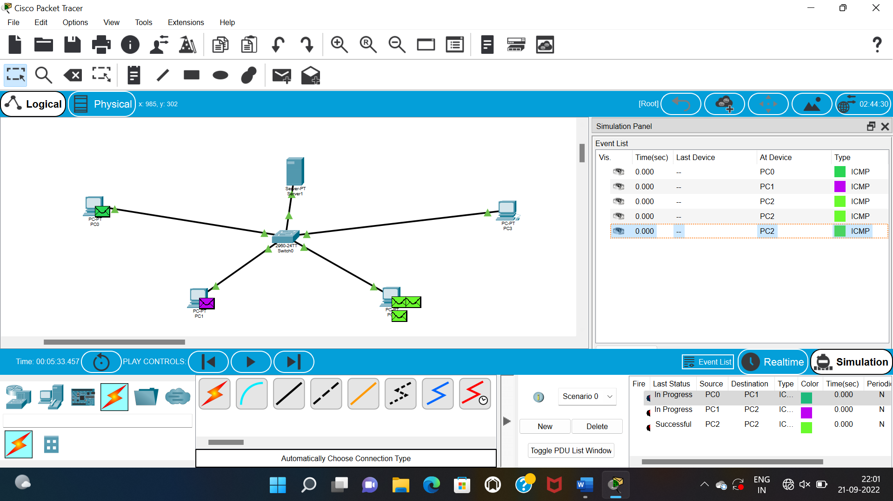

**EXPERIMENT 11**

**IOT BASED SMART HOME USING CISCO PACKET TRACKER**

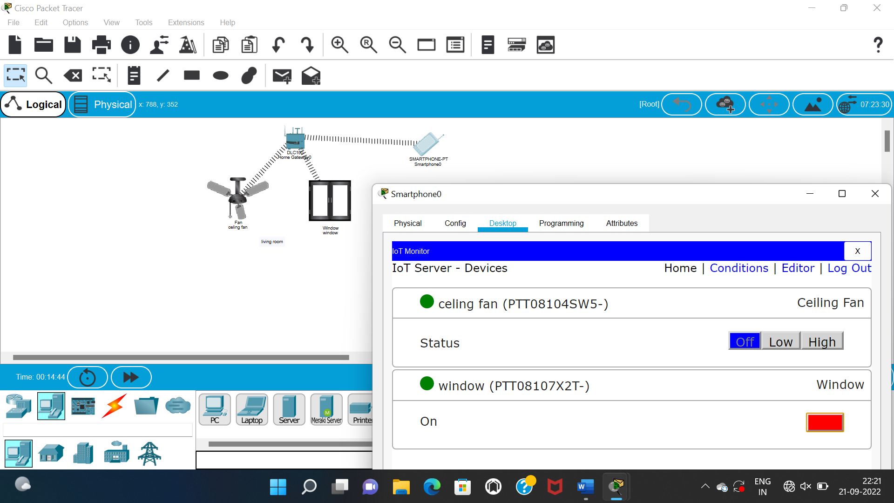

**EXPERIMENT 12**

**SMART GARDEN IN CISCO PACKET TRACKER**

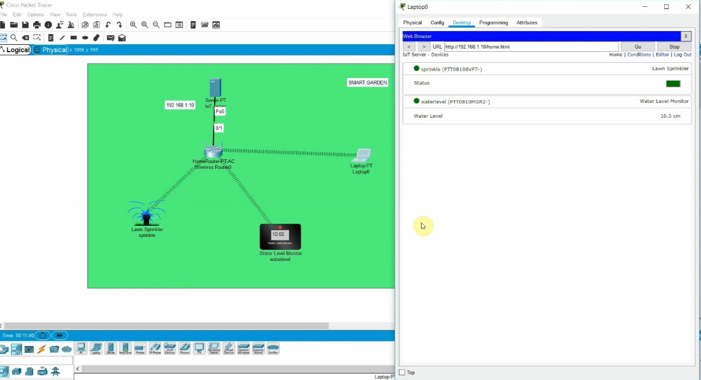

**Experiment 13**

**IOT DEVICES IN NETWORKING USING CISCO PACKET TRACKER**

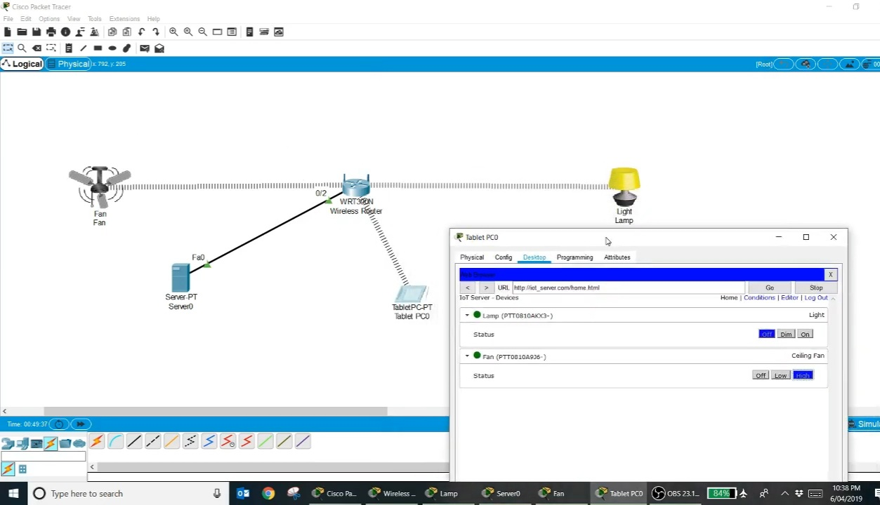

**EXPERIMENT 14**

**SIMULATING X,Y,Z COMPANY NETWORK DESIGN**

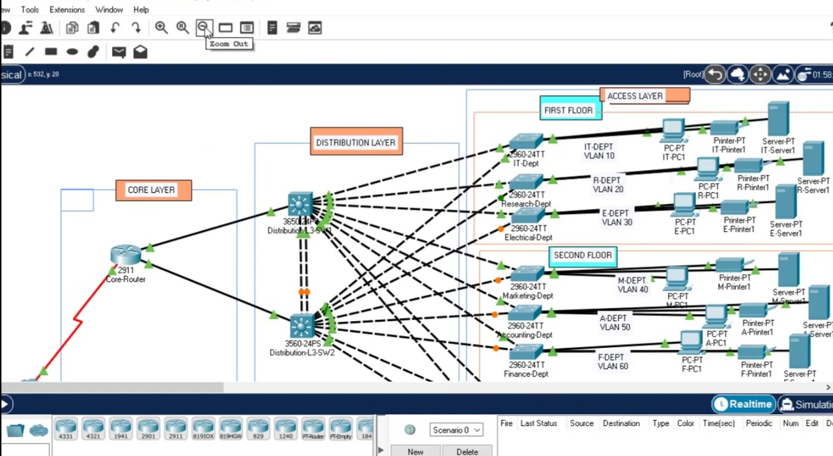

**EXPERIMENT 15**

**COMPUTER LAB IN CISCO PACKET TRACKER**

